Electronic Music Instrument
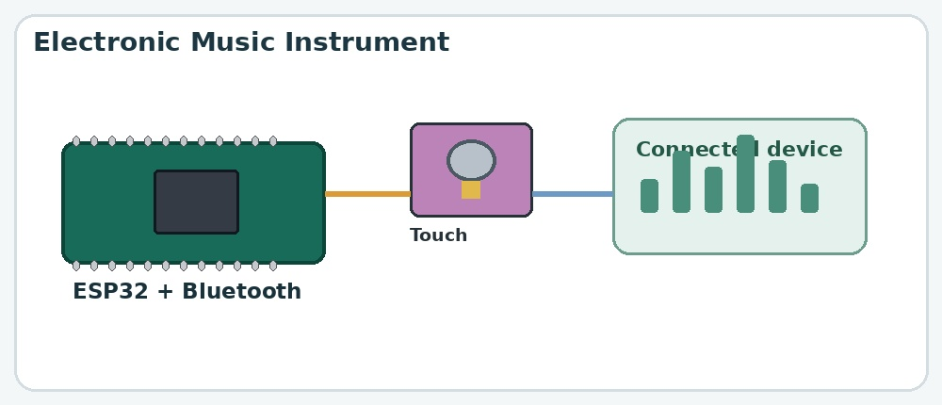

Aim
To create a touch-controlled electronic musical instrument that communicates with a device through Bluetooth.

What is the project?
A digital musical instrument in which touching a sensor triggers a musical note or sound command.

How does it work?
- The capacitive touch sensor detects contact with its sensing surface.
- It sends a signal to the ESP32.
- The ESP32 identifies the touch and executes the corresponding programmed instruction.
- The device is then connected to the Bluetooth of the ESP.
- A compatible device or music application produces the sound, in the configured Bluetooth.

Components used
- ESP32 microcontroller
- Capacitive touch sensor
- Jumper wires
- Bluetooth-compatible device

Connections
Component / Pin | Typical connection
Touch sensor VCC | 5V (ESP)
Touch sensor GND | GND (ESP)
Touch sensor OUT 1 | Pin 4 (ESP)
Touch sensor OUT 2  Touch sensor OUT 3  Touch sensor OUT 4 | Pin 15 (ESP)  Pin 13 (ESP)  Pin 12 (ESP)

